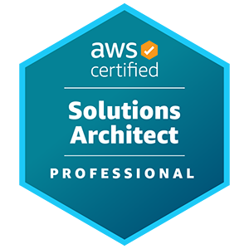
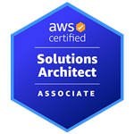
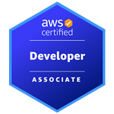
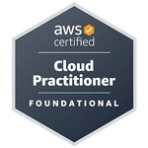
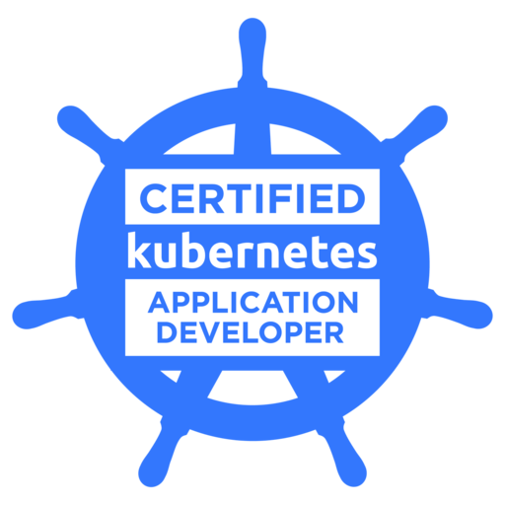
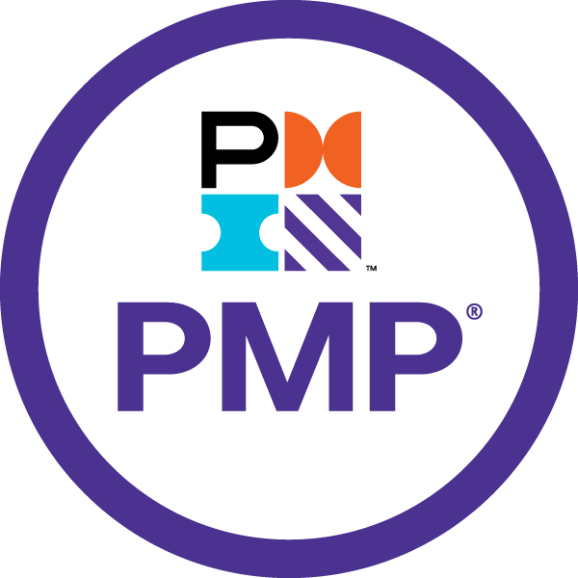
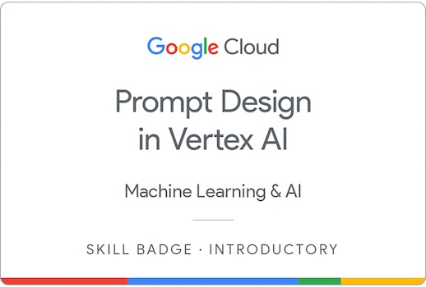
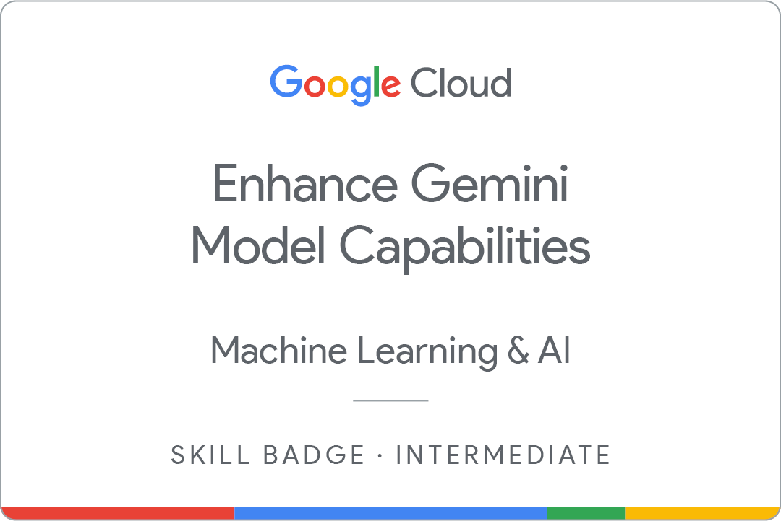
Mayank

Summary
- Enterprise Technology Leader with 25+ years of experience, specializing in AWS Cloud Architecture, Generative AI / GenAI, microservices, and enterprise-scale digital transformation, driving innovation and strategy as an AWS Certified Solutions Architect - Professional.
- Cloud Computing & Serverless Architectures: AWS Certified Solutions Architect – Professional, with deep expertise in Serverless Computing, Event-Driven Microservices, and multi-tenant SaaS platforms on AWS. Architecting and implementing AWS Cloud Solutions, Serverless computing, Containerization, and microservices to enhance business agility and scalability. Strong expertise in AWS services including Lambda, ECS Fargate, API Gateway, S3, DynamoDB, and Kubernetes(k8s), with hands-on experience in cloud-native and serverless application development.
- Generative AI / GenAI: Multimodal Data Processing and Analysis for text, Documents, audio, video, code generation using Prompt Engineering with Large Language Models (LLMs) / Foundation Models (FMs) like Gemini, Google Vertex AI, OpenAI. Using Retrieval Augmented Generation (RAG) for grounding model responses in external data to enhance accuracy and mitigate hallucinations, entity extraction, document classification and summarization, sentiment analysis, embeddings with Vector Databases, Grounding using Google Search, Tools and Internal Databases.
- Enterprise Architecture & Microservices: Strong background in architecting, designing and implementing scalable, Event-Driven and API-Driven microservices.
- DevSecOps & Infrastructure as Code (IaC): Proficient in AWS Cloud Development Kit (AWS-CDK), AWS CloudFormation, AWS SAM, CI/CD pipelines (Jenkins, GitLab, AWS CodePipeline), security tools (SonarQube, Fortify, Synk), and container security best practices.

Key Certifications & Honors

Generative AI / GenAI
- Enhance Gemini Model Capabilities Skill Badge from Google
- Prompt Design in Vertex AI Skill Badge from Google

AWS
- AWS Certified Solutions Architect Professional
- AWS Certified Solutions Architect Associate
- AWS Certified Developer Associate
- AWS Certified Cloud Practitioner

CNCF
- Certified Kubernetes Application Developer

Java
- Sun Certified Developer for Java Web Services (SCDJWS) for Java EE 5
- Sun Certified Business Component Developer (SCBCD) for Java EE 5
- Sun Certified Programmer for the Java 2 platform (SCJP)

MongoDB
- MangoDB for Java Developers from Mongo University
- MangoDB for DBAs from Mongo University

Banking Domain Certification
- Capital Markets and Investment Banking domain certified by Bank of America.

Project Management Certification
- Project Management Professional certified by PMI.

Awards
- Awarded Bank of America Platinum Global Recognition award for demonstrating exceptional Leadership in launching and driving the Technology Focus group at ITS level.
- Awarded Bank of America Spirit Platinum Points award for demonstrating exceptional performance in service delivery and living Bank of America’s core values.
- Awarded Certificate of Appreciation by Bank of America in recognition of outstanding performance in demonstrating the core values and achieving higher standards of service excellence.
- Awarded Certificate of Excellence by Kanbay (Capgemini) for going the extra mile, to meet client and Kanbay needs as project leader for GCS project.
- Awarded Certificate of Excellence by Kanbay (Capgemini) for a job well done as a part of the Technical Panel for Distributed Services recruitment.
- Awarded a Certificate of Merit by GE Financial Assurance for GENIUS project.
- Received Team award from Patni for GENIUS project.
- Awarded for Special Contributions made to GE-SOARS project.

Technical Skills
  - Technologies & Tools: Proficient in
★ Multi-Tenant SaaS Architecture on Cloud
★ Event driven Microservices architecture on AWS Cloud
★ Compute - AWS Serverless Architecture with AWS Lambda (λ)
★ Containers - Docker Containers, Kubernetes(K8s), Helm Charts, Elastic Container Services (AWS-ECS) - Fargate, Elastic Container Registry (AWS-ECR), Elastic Kubernetes Service (AWS-EKS)
★ API - Amazon API Gateway, REST APIs using Open API Specs (Swagger), CloudFront, GraphQL with AWS- AppSync
★ Application Integration / Messaging – Amazon SQS, SNS, CloudWatch Events /EventBridge, AWS Step Functions
★ Database / Streams / Migration / Transfer – AWS DynamoDB database, DynamoDB-Streams, Kinesis Data Streams, Kinesis Data Firehose, Amazon Timestream, Amazon Aurora for PostgreSQL, Amazon RDS for Oracle, AWS Data Migration Service (AWS-DMS), AWS Transfer Service
★ Security – AWS Cognito, OAuth2, AWS IAM, Secrets Manager, Encryption with AWS-KMS
★ Networking – Route 53, Elastic Load Balancers, Amazon VPC, VPC-Endpoint
★ Storage - S3 Bucket, Amazon EBS, Hosting Websites using S3
★ DevSecOps / Infrastructure-as-Code (IaC) with AWS Cloud Development Kit (AWS-CDK), AWS CloudFormation, Serverless Application Model (AWS-SAM), AWS Service Catalog, SAST Tools, SonarQube, Fortify, Synk, Twistlock, Container Image scanning, dependency scanning, binary scanning, CI / CD Tools - Jenkins, GitLab, AWS CodeCommit, AWS Code Pipeline, AWS CodeBuild
★ ElasticSearch, KIBANA, Splunk
★ NodeJS/Node.js, Javascript, TypeScript
★ Python 3.x
★ Java/J2EE, Spring/Spring Boot, Spring Data JPA/ ORM / Hibernate, SQL
★ AGILE Development.

Professional Experience – Summary

Brilliant Infotech Inc (Charlotte, NC, US) March 2018 - Present

Current Role - Principal Architect Clients - College Board, Fannie Mae, ETS, Wells Fargo
As a Principal Architect at Brilliant Infotech Inc, providing technology architecture consulting to different clients on AWS Cloud Architectures and Web-Application Architectures, enabling clients to develop Cloud-native platforms and architect solutions to re-platform applications for AWS Cloud.

AWS Cloud Architect - College Board February 2023 - June 2025
Technology: Event driven Microservices architecture on AWS Cloud, AWS Serverless Architecture with AWS Lambda (λ), AWS API Gateway, REST APIs using Open API Specs (Swagger), AWS AppSync GraphQL APIs, Route 53, CloudFront, Amazon DynamoDB database, DynamoDB-Streams, AWS EventBridge, AWS Simple Queue Service (SQS), AWS-SNS, AWS CloudWatch, ElasticSearch, AWS Transfer Service, OAuth2, Cognito, AWS-IAM, Encryption with AWS-KMS, S3 Bucket, AWS Service Catalog, AWS Cloud Development Kit (AWS-CDK), AWS CloudFormation, Infrastructure as Code (IaC), CI/CD, NodeJS, TypeScript, JavaScript, React, Jest, GIT, GitHub, AGILE Development

Providing AWS Cloud Architecture consulting for developing a multi-tenant Software-as-a-Service(SaaS) financial aid platform on AWS Cloud using Serverless technologies.
- AWS Cloud Architecture & Solution Design: Architect scalable, secure, and cost-effective cloud solutions using AWS services, guided by the AWS Well-Architected Framework and Enterprise Architecture (EA) standards.
- Serverless & Microservices Architecture: Architect event-driven, domain-aligned microservices using AWS Serverless technologies such as AWS Lambda, AppSync, SNS, and SQS, leveraging Domain-Driven Design (DDD) principles.
- Cloud Architecture Best Practices: Apply cloud-native architecture principles, organizational patterns, and IaC (Infrastructure-as-Code) to support DevOps practices and optimize cloud operations.
- Architecture Standards & Stakeholder Alignment: Define solution/application architecture standards and collaborate with cross- functional teams to align technical and business requirements.
- Modeling & Evaluation: Create architectural artifacts including systems/data models and workflow diagrams, and evaluate alternative architecture approaches based on performance, risk, cost, and compliance.
- Technology Strategy & Innovation: Drive cloud strategy and roadmap initiatives, validate architecture through PoCs, and research emerging technologies to enhance system flexibility and innovation.
- Leadership & Best Practices: Drive Domain-Driven Design (DDD), Cloud-native architecture and development best practices, while providing team leadership, coaching, and mentorship to developers. Also create architecture blueprints and proof-of-concepts (PoCs) following industry and AWS best practices.

Sr. Technology Architect / Portfolio Architect - Fannie Mae Jan 2022 - Jan 2023
Technology: Event driven Microservices architecture on AWS Cloud, AWS Serverless Architecture with AWS Lambda (λ), AWS Elastic Container Services (AWS-ECS) - Fargate, Elastic Container Registry (AWS-ECR), Docker Containers, APIGEE, REST APIs using Open API Specs (Swagger), Route 53, CloudFront, AWS RDS for Oracle, AWS Aurora DB, Amazon DynamoDB database, AWS Simple Queue Service (SQS), AWS-SNS, AWS CloudWatch, AWS-IAM, Encryption with AWS-KMS, S3 Bucket, AWS Service Catalog, AWS CloudFormation, Infrastructure as Code (IaC), CI/CD, Java, SpringBoot, GIT, AGILE Development

- AWS Cloud Architecture Leadership: Provide architectural leadership for the Single Family Loan Acquisitions portfolio at Fannie Mae, designing Minimum Viable Architectures (MVAs) and guiding cloud migration strategies using AWS services.
- Scalable, Resilient, Multi-Region Designs: Architect highly available, secure, and cost-optimized multi-region solutions on AWS, applying AWS Well-Architected Framework principles to support Disaster Recovery (DR) strategies with tools like Aurora Global Tables, DynamoDB Global Tables, and S3 cross-region replication.
- Modernization & Serverless Microservices: Lead modernization initiatives by applying Domain-Driven Design (DDD) to build event- driven microservices using AWS Lambda, SNS, SQS, and ECS Fargate, enabling scalable and decoupled service interactions.
- Legacy Application Migration & Replatforming: Develop re-platforming strategies to migrate legacy mainframe and on-premise systems to cloud-native containerized solutions using AWS Fargate and managed database services like Aurora PostgreSQL, Oracle RDS, and DynamoDB.
- Cloud Security & Data Governance: Implement AWS security best practices including encryption for data-in-transit and at-rest, private networking using VPC endpoints, and compliance with data governance policies for sensitive data classifications (e.g., PII/NPI).
- DevOps Enablement & Infrastructure Automation: Champion DevOps practices using Infrastructure-as-Code (IaC) via AWS CloudFormation and Service Catalog, along with CI/CD automation using Jenkins and UrbanCode Deploy (UCD) for seamless delivery pipelines.

Architect / Technology Leader - ETS Aug 2020 - Dec 2021
Technology: Event driven Microservices architecture on AWS Cloud, AWS Serverless Architecture with AWS Lambda (λ), AWS API Gateway, REST APIs using Open API Specs (Swagger), Route 53, CloudFront, Amazon DynamoDB database, DynamoDB-Streams, Kinesis Streams, AWS Simple Queue Service (SQS), AWS-SNS, AWS CloudWatch, AWS Batch, ECS, ECR, Elastic Search,AWS-IAM, Encryption with AWS-

KMS, S3 Bucket, AWS Service Catalog, AWS Serverless Application Model (AWS-SAM), AWS CloudFormation, Infrastructure as Code (IaC), CI/CD, NodeJS, TypeScript, JavaScript, React, Jest, GIT, GitHub, AGILE Development

The purpose of this program is to modernize ETS Advance Placement (AP) system from legacy Mainframe to Cloud Native Architecture using Serverless technologies. The project leverages Domain Driven Design (DDD) to identify various domains, and uses event driven Microservices architecture.
- Technology Leadership & Team Management: Provided architectural direction and hands-on technical leadership in solution design, coding, and developer mentorship, fostering high-performing Agile teams.
- Serverless Microservices Architecture: Designed and implemented event-driven microservices using AWS Lambda (Node.js), SNS, and SQS, with RESTful APIs managed via API Gateway and defined through OpenAPI specifications.
- Infrastructure Automation & CI/CD: Enabled DevOps practices through Infrastructure-as-Code (IaC) using AWS-SAM and CloudFormation, and streamlined deployments using Jenkins-based declarative CI/CD pipelines.
- Cloud-Native Data Solutions: Architected DynamoDB NoSQL data models with optimized GSIs, and implemented event triggers using DynamoDB Streams and Kinesis for real-time processing.
- Batch Processing & Containerization: Developed scalable batch solutions using AWS Batch and Docker containers orchestrated via ECS and stored in ECR, enhancing compute efficiency.
- Cloud Security & Testing Strategy: Enforced AWS security best practices using IAM roles and KMS encryption, and ensured code quality through unit/integration testing frameworks (Mocha, Chai, Sinon, etc.) with local development supported by SAM CLI and Docker.

Architect / Technology Leader - Wells Fargo Apr 2018 - Jul 2020
Technology: Java 8, J2EE, Spring, SpringBoot, Spring REST / MVC, Spring Data JPA, EhCache, Hibernate, Bean Validation, Unit, Mockito, Angular 9, Oracle, PL/SQL, IBM MQ, Autosys, Gradle, Jenkins, GIT, JIRA, AGILE Development

The purpose of this program was to develop a loan availability monitoring / portfolio monitoring solution to support Wholesale lending capabilities. The project/program replaces two legacy applications, Borrowing Base Reporting (BBR) and the Credit Online Transaction System – Budget Tracking (COLTS BT), that are currently utilized to monitor the Commercial Real Estate (CRE) Homebuilder Portfolio.
- Technology Architecture & Leadership: Led the architecture and technical design for Credit Bridge Asset Management’s Loan Availability Monitoring and Portfolio Monitoring platforms, providing end-to-end guidance from solution design to implementation, while mentoring developers and managing team deliverables.
- Enterprise Integration & Real-Time Systems: Designed secure, real-time integration solutions with external systems using RESTful APIs (with mTLS) and IBM MQ Series, ensuring robust, low-latency data exchange and system interoperability.
- Backend Architecture & Modern Java Development: Built scalable backend services using Spring Boot and Spring REST, employing advanced Java 8 features such as Lambdas, Streams, and CompletableFutures for asynchronous and parallel programming.
- Database Architecture & Performance Optimization: Designed relational data models and implemented the persistence layer using Hibernate and Spring Data JPA, with a strong focus on domain-driven design, SQL performance tuning, and entity modeling.
- Software Design & Code Quality: Championed object-oriented design (OOAD) principles and design patterns, led code reviews, enforced high coding standards, and improved application performance through refactoring and optimized query execution.
- DevOps & Agile Delivery: Streamlined development workflows using Jenkins and IBM UrbanCode Deploy (UCD) for CI/CD, and delivered iterative value through Scrum-based Agile methodology with 3-week sprint cycles.

CRISIL - A Standard & Poor's Company (Mumbai, India) August 2014 - March 2018

Director of Technology
Technology: Java, Spring, Spring Boot, Spring Cloud, Spring REST / MVC, Spring Data JPA, Spring Security, Amazon Web Services (AWS), J2EE, Angular 5 / AngularJS, MongoDB, Struts, Spring-Batch, Web-Services, Spring Integration, Bean Validation, XML, Ehcache, IBM Websphere, SQL, PL/SQL, Oracle

- Technology Leadership & Strategy: Directed technology architecture, design, and software development for CRISIL Ratings IT platforms, collaborating with the CTO and business leaders to define platform vision and roadmap.
- Enterprise Architecture & Governance: Participated in the Architecture Review Board (ARB), providing thought leadership and strategic oversight on architectural decisions across all major IT projects.
- Cloud & SaaS Solution Architecture: Designed and architected cloud-native solutions, including a multi-tenant, multilingual SaaS product for Lending Business and a Spring Boot Microservices based marketplace for SME institutions on AWS.
- Software Development & Innovation: Led the Java/Solutions Center of Excellence (CoE), defining best practices and technology strategies while also developing a mobile app for the Ratings Business using Spring REST-based APIs.
- Agile Delivery & Vendor Management: Managed cross-functional teams and external vendors to execute Agile-driven software development, ensuring seamless sprint execution and high-quality deliverables.

JP Morgan Chase (Hyderabad, India and Mumbai, India) September 2011 - July 2014

Vice President (VP)
Technology: Java, J2EE, Struts, Spring, Spring MVC, Spring Web-Flow, Web-Services, Spring Integration, Bean Validation, iBATIS / MyBATIS, XML, Ehcache, IBM Websphere, SQL, PL/SQL, Oracle
Projects Undertaken:

Project Name | Period
Life Insurance & Annuities platform | Multiple projects during Sep-2011 to Jul-2014
Broker Dealer Support Services (BDSS) platform
Anti-Money Laundering (AML) platform

- Technology Architecture & Design Leadership: Provided architectural guidance and technical design solutions for Chase Wealth Management IT, ensuring alignment with platform vision and enterprise technology standards.
- Software Development & Agile Delivery: Led Agile and Iterative Sprint teams, managing internal and vendor development teams to deliver high-quality system updates and releases.
- End-to-End Solution Management: Conceptualized, planned, and executed multiple projects, overseeing scope, time, cost, quality, risks, and resource management within the portfolio.
- Collaborative Development & Quality Assurance: Worked closely with business analysts to define system requirements and ensured the quality of design and code through rigorous reviews and controls.

BA Continuum Solutions - Bank of America (Hyderabad, India) Nov 2007 - Sep 2011

Assistant Vice President (AVP)
- Technology Leadership & Solutions: Led a team of 75+ IT professionals in Enterprise Change, Technology, and Operations (ECT&O), focusing on middleware, database, and OS technologies. Established the Middleware Technology Focus Group (TFG) in India to drive innovation and expertise.
- Strategic Engagement & Project Management: Collaborated with senior technology leaders to define and execute project management and business strategies for the Merrill Lynch transition and multiple project migrations to India.
- Architecture & Migration Expertise: Played a key role in project migration strategies from onshore locations to BACS, ensuring seamless transitions and operational efficiencies.
- Vendor & Talent Management: Led vendor rationalization efforts and facilitated the re-badging of key talent from vendor organizations to BACS. Spearheaded performance metrics standardization, reporting, and dashboard initiatives across ITS.

Kanbay / Capgemini (Hyderabad, India and Chicago, US) Aug 2003 - Oct 2007
Project / Program Manager, Delivery Manger - HSBC, Total Systems(TSYS, Europe), GE Money (Asia) Technology: Java, J2EE, Struts, Spring, Hibernate, XML, Web Services, MQ Series, IBM Websphere, JBoss, SQL, DB2, Oracle Projects Undertaken:

Project Name | Period
Global Collections System (GCS) | Nov-2003 to May-2004
Consumer Lending and Mortgage | May-2004 to Sep-2005
Execution Services Training & Mentoring Services | Sep-2005 to Oct-2006
Oasis Premium Statements | Nov-2006 to Dec-2006
Banco Santander Pre-paid Card Customer Portal | Jan-2007 to May-2007
Internet ASIA COE Project | Jun-2007 to Oct-2007

- Enterprise Web Solutions & Project Leadership: Led large-scale web development projects for GE Money and HSBC, delivering solutions in consumer lending, mortgages, and credit card services, managing teams of up to 40+ associates.
- Technology Architecture & Mentorship: Designed and mentored HSBC’s global workforce on web development architecture, overseeing

training programs in the US and UK to enhance technical capabilities.
- Financial Services & Payment Systems Expertise: Delivered trade settlement and credit card portal solutions for HSBC and Santander, integrating financial messaging via SWIFT and CHAPS gateways for seamless transaction processing.
- Software Delivery & Account Management: Managed the Total Systems (TSYS) Europe account in the credit and prepaid card space, overseeing offshore development/testing teams, RFPs, SOW creation, and ensuring customer satisfaction.
- Global Delivery & Stakeholder Management: Managed end-to-end project execution using a global delivery model, ensuring seamless collaboration across regions, optimizing resources, and maintaining stakeholder alignment.

Patni Computer Systems (Mumbai, India and Virginia, US) Sep 1998 - Aug 2003

Developer / Sr. Developer / Lead - GE Financial Assurance (GEFA)
Technology: Java, Swing, J2EE (servlets, JSP, EJB, JMS), XML, Struts, IBM MQ Series, IBM Websphere, iPlanet, JRun, SQL, Oracle
Projects Undertaken:

Project Name | Period
GE New Insurance and Underwriting System (GENIUS) | Nov-2001 to Aug-2003
Status of Outstanding Appointments Requirements (GE-SOARS) | Apr-2001 to Oct-2001
CSE Agent Admin Tool | Nov-2000 to Mar-2001
Quoting Engine Admin Tool | May-2000 to Oct-2000
Policy Data Quickly (PDQ 2000) | Jan-2000 to April-2000
Case Manager Front End (CMFE) | Sep-1998 to Dec-1999

- Object Oriented Design & Software Development: Architected and implemented robust software solutions using object-oriented analysis and design (OOA/D), UML, and design patterns; developed reusable framework components and enterprise applications across the full SDLC using Java, J2EE (Servlets, JSP, EJB, JMS), XML, and Swing.
- Leadership & Coordination: Led cross-functional teams in delivering middleware components integrating Mainframe, Email, and Fax systems via MQ Series, leveraging Java/J2EE Messaging and coordinating global teams as a Module Lead and Onsite Coordinator to ensure stakeholder satisfaction and timely delivery.
- Business & Technical Integration: Bridged business and technical teams by capturing and translating business requirements into actionable software specifications, managing offshore deliverables, and ensuring alignment with project goals and quality standards.

Education
- Post Graduate Diploma in Software Application Engineering - PGDSAE (1998), 6 Months – Full Time, Boston’s computer Institute, Mumbai.
- Bachelor of Engineering (1995), 4 Year Graduation Course, Dayalbagh Educational Institute, Agra.

Professional Organizations

Organization | From | To | Location
Brilliant Infotech Inc. | Mar 2018 | Till Date | Charlotte, NC USA
CRISIL, An S&P Global Company | Aug 2014 | Mar 2018 | Mumbai, India
J P Morgan Services India Pvt. Ltd. | Sep 2011 | Jul 2014 | Mumbai, India
BA Continuum Solutions (Bank of America) | Nov 2007 | Sep 2011 | Hyderabad, India
Kanbay (Capgemini) | Aug 2003 | Oct 2007 | Hyderabad, India & Chicago, IL USA
Patni Computer Systems | Sep 1998 | Aug 2003 | Mumbai, India & Lynchburg, VA USA
MICO Bosch (non-software) | May 1996 | Jan 1998 | India
Greaves Ltd. (non-software) | Aug 1995 | Apr 1996 | India

